Health & Safety Policy

Statement of Intent

Compliance and Commitment

The Company commits to ensuring, as far as reasonably practicable, the health, safety, and welfare of our employees and others affected by our operations. We aim to:
- Control risks from work activities.
- Consult with employees on health and safety matters.
- Provide safe working conditions and equipment.
- Provide necessary training and supervision.
- Prevent accidents and health issues.
- Comply with relevant Health, Safety and Fire legislation.
Directors Responsibilities:
- Implement and adapt the health and safety policy as needed.
- Ensure sufficient resources are allocated to meet safety objectives.
Management Responsibilities:
- Prioritise health and safety to prevent injuries and property damage.
- Protect all persons from foreseeable risks.
Employees Duties and Consultation:
- Employees are informed of their duties under this policy.
- Regular consultation with employees to integrate their feedback and improve safety practices.

Systematic Safety Management

We have implemented arrangements to support the effective implementation of this health and safety policy and we commit to:
- Identify hazards, assess risks, and determine control measures.
- Ensure all employees understand and follow the necessary safety procedures.
- Prepare emergency procedures, including evacuation in case of fire or other significant incidents, are clearly set out and communicated to all staff.
We view health and safety legislation as a minimum standard to exceed, expecting management to meet their targets without compromising safety.

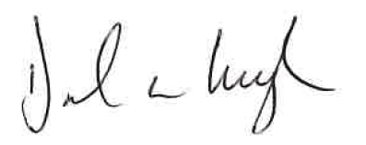
Signed: Date: 01/03/25

