Lone Worker Policy
Higher Risk activities or locations
- Wherever practicable, employees of Betterclean Services are not to work alone in higher risk activities or areas.

- Where lone working is unavoidable, the lone worker will ensure that their Supervisor is aware of their whereabouts and the nature of the work being undertaken.

- The lone worker will make contact with their Supervisor on completion of the activity or at the end of the shift as a minimum. (this can be achieved through the use of the Ezitracker system)

Normal activities or locations
- Employees are to use the Ezitracker systems to log in and out of each site.

- Where lone working is unavoidable, the lone worker will ensure that their Supervisor is aware of their whereabouts and the nature of the work being undertaken. (this is achieved through the routine scheduling of work and the use of Ezitracker)

- The lone worker will make contact with their Supervisor on completion of the activity or at the end of the shift as a minimum. (this can be achieved through the use of the Ezitracker system)

RESPONSIBILITIES
Manager
- Must be aware of their managerial responsibilities under the Policy and ensure that they extend fair treatment to all employees, contractors and associated personnel.
- Must take an active role in raising awareness of the Fair Treatment Policy to new and existing employees
- Should ensure that no employee suffers discrimination, harassment, victimisation or other detrimental treatment by another employee

Individual
- Must remain aware of and adhere to the Company’s Equal Opportunities Policy and, where found guilty, will be personally responsible for any individual cases of discrimination, harassment, victimisation or any other detrimental treatment
- Should report any breaches of the Policy in respect of themselves or any other employee or associated person, and/or, if requested, provide information about any such breaches
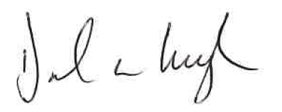
Signed: Date: 01/03/25

